**DBMS: LAB 3**

**DDL (Data Definition Language) Commands**

**University Fest Management System**

**OBJECTIVE:** To learn and understand DDL statements while executing queries.

DDL (Data Definition Language) queries in MySQL are used to define and manage the structure and characteristics of your database and its objects.

Some of the important DDL commands are:

* **CREATE:** This DDL query establishes a new database object, such as a table or an index, with defined attributes and structure.
* **ALTER:** The ALTER query modifies the structure of an existing database object, enabling tasks like adding or modifying columns.
* **TRUNCATE:** This DDL query removes all the data from a table while retaining the table structure, resulting in improved performance compared to the DROP TABLE query.
* **DROP:** This DDL query deletes a database object, such as a table or an index, along with its associated data irreversibly.
* **RENAME:** The RENAME query changes the name of an existing database object, like altering the name of a table.

**INSTRUCTIONS:**

* As a part of LAB 3, there are 2 tasks that are to be completed wrt to the case study shared earlier with ER diagram and Relational Schema of University Fest Management.
  + **TASK 1:** As per the given Description, ER diagram and Relational Schema – create the tables using DDL commands and add the required constraints.
  + **TASK 2:** There are certain questions that have been given. These are to be executed on the DDL statements created in TASK 1.
* As a part of the submission process, the following are to be submitted:
  + A **PDF** document, containing all the Screenshots for both tasks as suggested
    - Name of the file: `<your SRN>_University_Fest_DB_Lab3.pdf
  + The **“.sql”** file for the same, shall contain all the commands that have been executed in the lab
    - Name of the file: `<your SRN>_University_Fest_DB_Lab3.sql

**Example:**

Refer to the sample submissions given below. This will give you an idea about the details that must be included in your submissions

**NOTE:** Screenshots can be taken either from “**MySQL workbench”** or “**Command Line”**

**Task 1:**

Take the screen shot of every table created along with the create table sql command.

**Task 2:**

Task 2 involves modifying the structure of the tables created in Task 1. For every modification made, **3 screenshots** are required:

1. Structure of the table **before** modification
2. **DDL statement**
3. Structure of the table **after** modification

Sample submission:

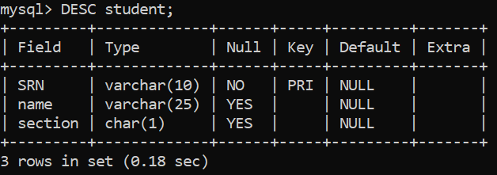

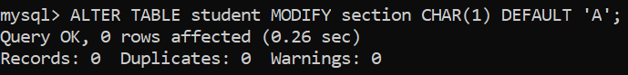

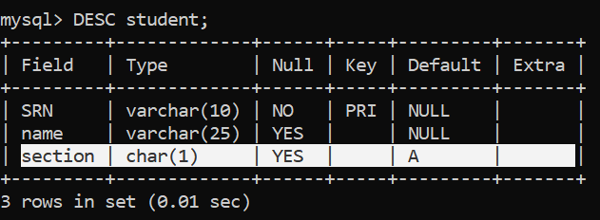

**TASK 1:**

Identify all the constraints (domain, key, constraint on null, primary key, foreign key and check etc) based on the ER and description given and execute the DDL commands for University_fest database.

Add all the screenshots of sql command and desc table.

**TASK 2:**

1. **Modify the datatype of the gender attribute to make sure that the only values that can be stored are M: for male, F: for female, and O: for other. Also, make sure that the gender attribute is positioned after the "name" column.**

Before: --describe the table/s

Command – sql command

Afer: --describe the table/s

1. **Every stall would offer items for different prices, it is found in the previous fests that the price of most of the items was 50. Therefore as a DB designer, set the default value of the prices of items to be 50 rupees and also make sure that every item has a price associated with it meaning we cannot have a null value entered into the price.**

Before: --describe the table/s

Command – sql command

Afer: --describe the table/s

1. **Considering that the stalls have a limited space for storing the various items they sell, create a max_stocks condition that ensures that a particular stall can at max have 150 units of each item that they sell.**

Before: --describe the table/s

Command – sql command

Afer: --describe the table/s

**4: Rename the table “Event_conduction” to “Event_schedule”**

Before: --describe the table/s

Command – sql command

Afer: --describe the table/s

**5: Move the column "Date_of_conduction" such that it’s the first column**

Before: --describe the table/s

Command – sql command

Afer: --describe the table/s

**Task 3: Few questions for you to answer:**

1: Which is the sql command to know the current database in MySQL?

2: Which is the sql command to clear the command prompt window of MySQL?

3: Can you rename the database in MySQL?

4: What is the command to remove a table along with its structure?

5: Specify the difference between drop table and truncate table?

6: Can a table have more than one primary key?

7: Can a foreign key value be null?

8: Can a primary key value be null? Which constraint is this?

9: Upon describing the table using the command “desc tablename” what information about the table is given.

10: Can a primary key for a table be changed? If yes how?